Git -1

Examples from class
- Git is already in gitbash by default. so, updated it by using command
Yum update git
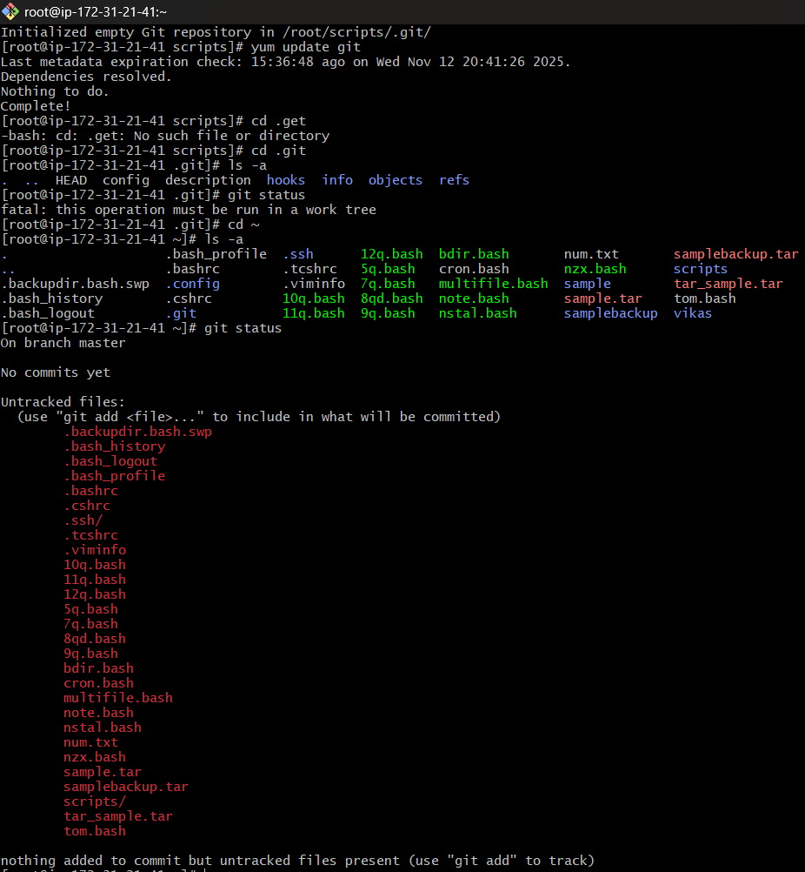

- Using command git config - -list , when we are this for first time. We need to configure and add user name and user email ID.
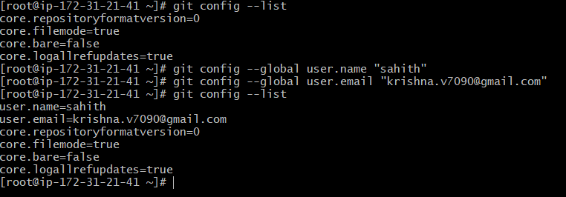
- In this we are connected to the git respository. Initialized empty git repository
- If we ls we can see few hidden files which ‘.’ Current directory, ‘ .. ‘ parent directory,
- .git represents git metadata directory
- By using git add command it start tracking
- Get status is used to check the status of an tracking or untracking
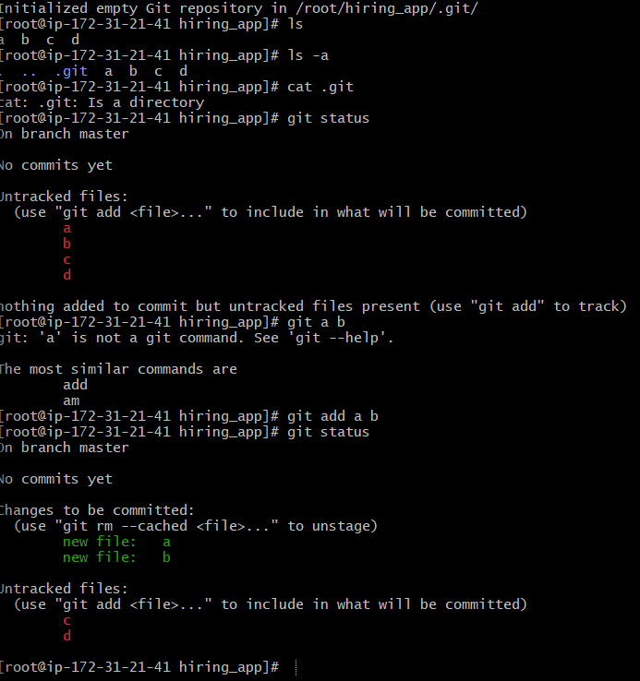
- We commit -m because without commiting our work is not saved in git history.
- We git log to show the history of commits we made.

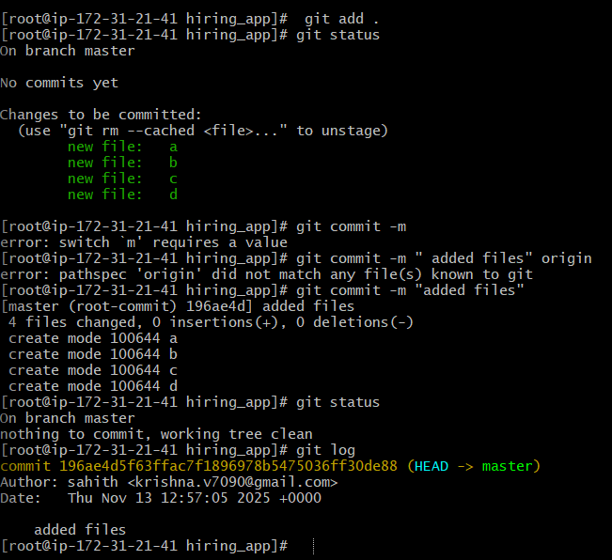
- Using ssh-keygen created an key and pasted in the github

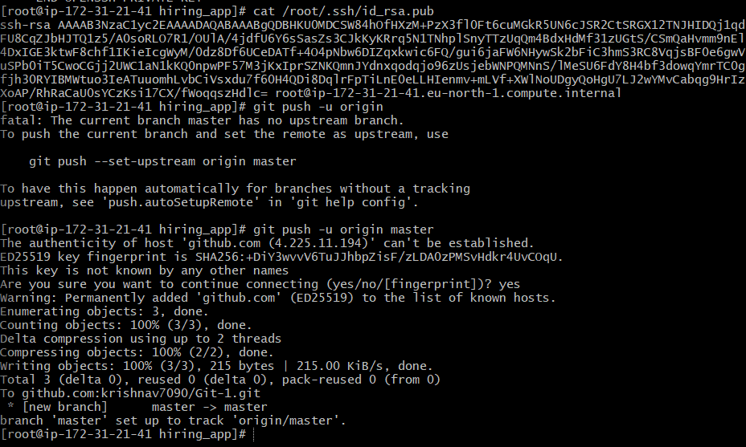

- Created files a, b, c & d in local repo and used git add . , git commit-m and git push
- In the below screenshot that files are pushed from local.
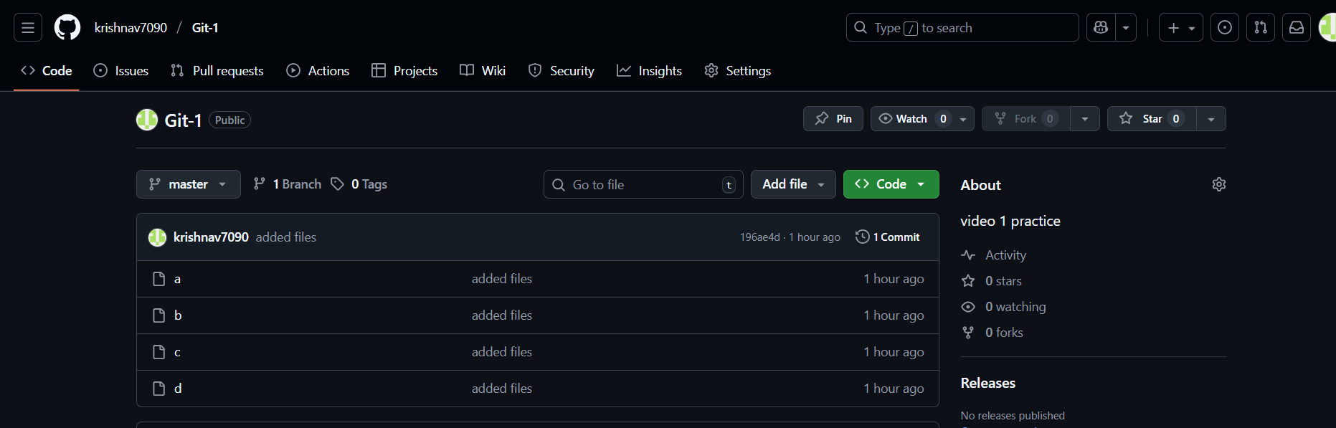

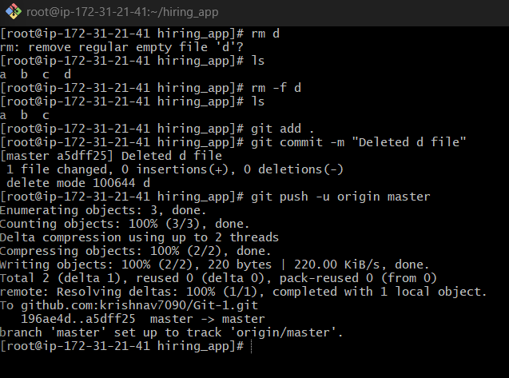
- Files d is removed in local and updated using git add, git commit, git push

